Name: Sunny Jovita

Binus ID : 2301939046

1. First UML diagram

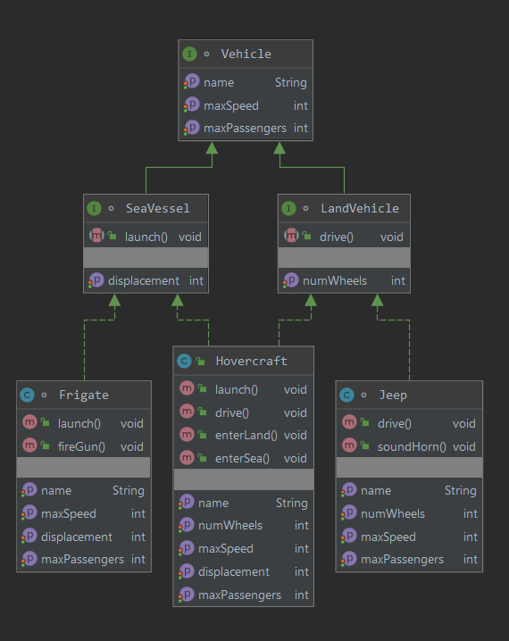

1. New UML diagram

